DIS-PAC-POLY-Marquesas Adze from Hawaii-RARE

# Marquesan Basalt Trilateral Adze. Extremely rare as this is one of the few basalt adzes that have the trilateral (three sided) style found in Hawaii that demonstrate the tradition of Marquesan adze style in the Hawaiian Islands. This example, found in Kohala district on the Island of Hawai’I, suggests a Marquesan presence on the island at an early time, further supporting the argument that Hawai’i was settled originally by Marquesans.

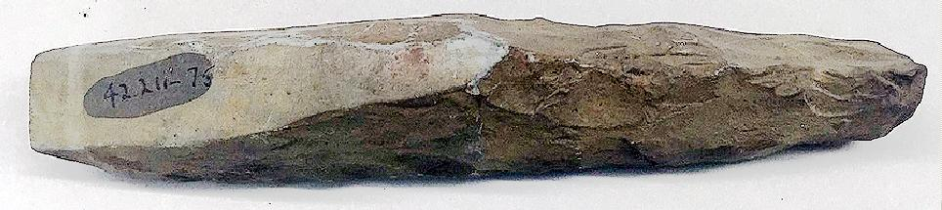

Marquesan trilateral basalt adze, Brooklyn Museum 3 1/8 x 1 5/16 x 1 3/4 in. (8 x 3.3. x 4.5 cm), A. Augustus Healy Fund, 42.211-75. (Photo: Brooklyn Museum, CUR.42.211.75.jpg).